**Graphs in Every Day Life Assignment**

Amit Pandit 04-09-2019, Coursera, Big Data Specialization– UC San Diego

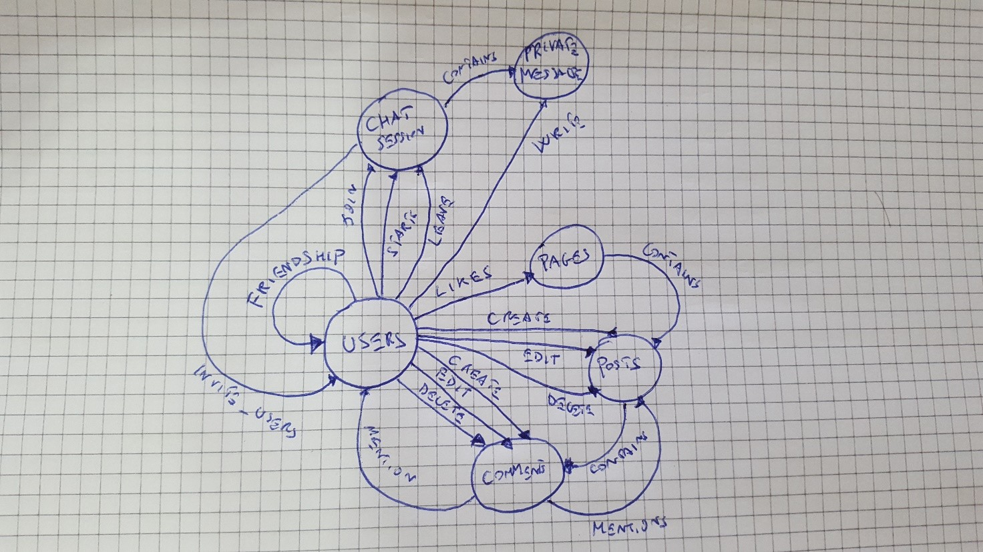

I thought a simple Social Network with a basic functionality such as create posts, comments them, ask friendship, chat and likes pages. Below the lists of nodes and edges.

A Social Network like this could provide tons of questions and answers, for example:

* **Who are the influencer of the network?** Users with lots of friends and Pages with lots of likes are the best candidates to be defined as such. A useful metric is Degree of Centrality.
* **What are the trending topic/posts?** We can retrieve the trending topic based on the numbers of interactions such comments and likes and compute TF-IDF for each returned comment.
* **What are the most active Users?** Users (or Pages) with N likes or comments X day (maybe 10?) is very active!
* **What are the suggested Users for each User?** We should find the closest non-friend neighbors and suggest to each user respectively.

|  |  |
| --- | --- |
| **ID** | **NODE** |
| **1** | Users |
| **2** | Pages |
| **3** | Posts |
| **4** | Comments |
| **5** | Chat Sessions |
| **6** | Private Messages |

|  |  |  |
| --- | --- | --- |
| **SRC_ID** | **DST_ID** | **EDGE_TYPE (E)** |
| **1** | 1 | Friendships |
| **1** | 2 | Likes |
| **1** | 3 | Creates |
| **1** | 3 | Edits |
| **1** | 3 | Deletes |
| **1** | 4 | Creates |
| **1** | 4 | Edits |
| **1** | 4 | Deletes |
| **1** | 4 | Likes |
| **1** | 5 | Starts |
| **1** | 5 | Leaves |
| **1** | 5 | Joins |
| **1** | 6 | Writes |
| **2** | 3 | Creates |
| **2** | 3 | Edits |
| **2** | 3 | Deletes |
| **2** | 4 | Creates |
| **2** | 4 | Edits |
| **2** | 4 | Deletes |
| **4** | 1 | Mentions |
| **4** | 2 | Mentions |
| **5** | 1 | Invite |
| **5** | 6 | Contains |
| **2** | 3 | Contains |
| **3** | 4 | Contains |